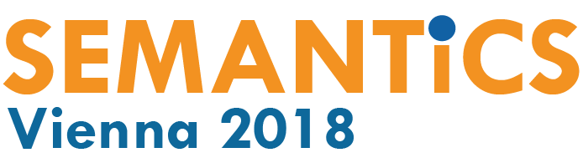

"Automate Chaos - and You'll Get Automated Chaos"
Technology meets business - SEMANTiCS 2018

Digitally, it's easy to gauge or measure almost anything, huge amounts of data and information are available. However, only few enterprises have a dedicated strategy in place though to manage data and information. Most managers are aware of the importance and impact big data, artificial intelligence and semantic technologies will have in the coming years and how they will influence competition and competitors alike, yet there's no clear idea on where to start. Integrating megatrends into enterprise processes and workflows will only be one of the subjects the SEMANTiCS 2018 will cover. The international conference will take place for the 14th time from 10th - 13th of September 2018, and provide information about state-of-the-art semantic systems, and representatives of high-tech research and business will gather - this time in the Hilton Waterfront Hotel, Vienna and the Technische Universität Wien.

The importance of data for any business's success has been agreed upon for some time. But yet, even armed with knowledge, there exists a huge gap yet between strategic management expectations on the one hand and actual projects executed and finished according to them on the other. One of the reasons is the fact that data are underestimated as a valuable resource in business practice today. And as soon as data should be analysed the impossible is expected from those analyses. Data analysts are supposed to let come to life what is in effect a data silo extracted from multiple databases for big data. Businesses and enterprises tend to be too slack yet to create a basis for such agile data analyses. "This jeopardizes one of the most important competitive advantages a company can have, a sustainable data landscape. If you automate chaos, you will get automated chaos." Andreas Blumauer, CEO of Semantic Web Company says. The Semantic Web Company together with the Technische Universität Wien, University of Leipzig, Vrije Universiteit Amsterdam and Fachhochschule St. Pölten hosts this event.

The SEMANTiCS 2018 lectures and workshops will introduce projects that show how management and actually whole enterprises can profit by semantically structured data. Topics covered range from process optimizing for enterprises, next generation customer experience, information management to agile data integration on different levels. After individual events discussion is welcome with all high-tech experts as well as lecturers present about the future of big data and AI. The five keynote address will be held by prominent experts in their fields from the US and Europe, among them Daniel Rosenberg, professor of history in Oregon and Elena Simperl, professor for information technologies in Southampton. Both of them are focusing attention on people: Rosenberg examines implications of new data-driven approaches in the humanities, Simperl is in particulier interested in socially and economically-motivated aspects of creating and using semantically enabled content on the Web.

To schedule interviews, contact Dr. Susanne Ardisson:
susanne.ardisson@semantic-web.com

Find images here.

Conference data:
SEMANTiCS 2018:
Conference dates: 10.-13.09.2018 (http://www.semantics.cc)
Workshops 10. and 11.09.2018 (http://www.semantics.cc/programme/workshops/)
Tickets from 350,- € (http://www.semantics.cc/registration)
Location: Hilton Vienna Danube Waterfront, Handelskai 269, 1020 Vienna, Austria
Responsible: Semantic Web Company, Technische Universität Wien, Universität Leipzig, Vrije Universiteit Amsterdam and Fachhochschule St. Pölten

About SEMANTiCS Conference:
Founded in 2005 the SEMANTiCS conference covers latest developments in and future outlooks on semantic technologies and their implementation. Semantic technologies are used to process meaning, an important feature for AI and smart systems. The conference is geared towards decision-makers, researchers and IT-consultants. The motto of the conference 'Transfer / Engineering / Community' gathers numerous lectures, workshops and discussion panels for this event that highlight the semantic technologies-based applications already implemented or that will be put to use in the near future.
SEMANTiCS is supported by an international consortium of science and enterprise. This year's event is hosted in a combined effort by the Semantic Web Company, the Technische Universität Wien, University of Leipzig, Vrije Universiteit Amsterdam and Fachhochschule St. Pölten.

